Automatic Engine Idle Shutdown (AEIS) Control Function & Warning Messages – CGEA1.3

Functional Description

This STSS handles the Automatic Engine Idle Shutdown (AEIS) feature, which will shut off the engine on a vehicle which sits at idle with no inputs from the driver for a period of time (30 minutes) in order to help improve fuel economy.

This feature is implemented with and without customer override capability. The variation without customer override was first introduced to meet CARB emissions requirements and would shut off the engine after 5 minutes engine idle speed (in park) and 15 minutes engine idle speed if in non-Park gear. When the engine is within 30 seconds of a shutdown event the IPC displays a warning indicating the engine will shut off in XX seconds and counts down to 0 seconds upon which time the engine shuts itself off. Upon the engine shutting itself off a message is displayed for 30 seconds indicating that an engine shutdown event has occurred. After the 30 seconds of the engine shutting itself off the ignition will turn itself off.

For the non-regulated version, AEIS function will be similar to the regulated version except the customer is able to override the impending engine shutdown from the 30 second countdown message by pressing the "ok" button while the countdown message is displayed. The text "press ok to override" is added to the countdown message to inform the operator of this capability. This override is for the current key cycle only. The non-regulated version also provides the capability to override the AEIS via the settings menu. The AEIS override via the message center settings menu is for the current key cycle only (Next key cycle AEIS resets to ON).

For this feature a command / stat message signal pair is NOT employed. If the non-regulated AEIS feature is overridden by the customer the IPC sends out EngIdlShutDown_B_RqDrv = 0x1 (Inhibit) for that key cycle and PCM/ECU then inhibits the shutdown feature. IPC will default to EngIdlShutDown_B_RqDrv = 0x0 (no inhibit) upon entering Normal or Crank modes.

If the customer decides they want the non-regulated feature permanently disabled they may have the dealer set the configuration bit to inhibit. EngIdlShutDown_B_RqDrv output is then permanently set to 0x1 (inhibit).

If the AEIS without override (regulatory) feature is configured ON then the countdown with override message is replaced by the 30 second countdown message without override, and the AEIS override settings screen is not present in the menu. Currently there are no regulated applications for AEIS. The AEIS without override (regulatory) is incorporated to protect for potential future application.

Starting in MY2019 with U625/U611 the Settings are migrating from the cluster to Center stack. This STSS supports displaying settings in the cluster or configuring the cluster settings off if they are displayed in the Center stack. When configured for settings in the Center Stack, for this feature, the cluster acts as a signal gateway between the Center Stack and the PCM/ECM module. Any feature setting that the cluster acts as gateway for by definition only has one setting (i.e. the setting is not part of Enhanced Memory). Thus, the requested Index from the Center Stack is always just copied back in the IPC response.

For this feature, even when the settings menu is in the Center Stack, the cluster will still display W668 “Press OK to Override” popup.

Interfaces

Interface Context Diagram (I/O Block Diagram)
Figure 1 Automatic Engine Shutdown Function Context Diagram
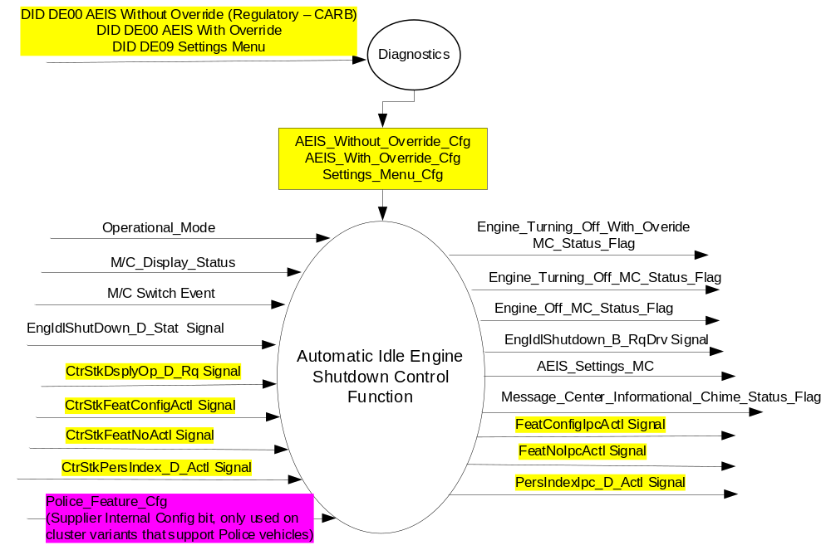

Inputs

- INTERNAL:
- Operational_Mode
- M/C Switch Event
- AEIS_Without_Override_Cfg
- AEIS_With_Override_Cfg
- Settings_Menu_Cfg
- Police_Features_Cfg – (Refer to Warning – Police idle System – CGEA 1.3 STSS)
- M/C_Display_Status
- AEIS_Settings_MC
- MUX message on the CAN bus from PCM/ECM:

- EngIdlShutDown_D_Stat Signal
Signal Name | Size  (bits) | Detail | Units | Res. | Offset | State  Encoded | Min | Max
EngIdlShutDown_D_Stat | 2 |  | SED | 1 | 0 |  | 0  (0x0) | 3  (0x3)
 |  | Normal_Operation |  |  |  | 0 (0x0)
 |  | Initiated_Countdown |  |  |  | 1 (0x1)
 |  | Engine_Shutdown |  |  |  | 2 (0x2)
 |  | Not_used |  |  |  | 3 (0x3)

- MUX messages on the CAN Bus from APIM:

- CtrStkFeatConfigActl Signal
Signal Name | Size  (bits) | Detail | Units | Res. | Offset | State  Encoded | Min | Max
CtrStkFeatConfigActl | 16 | - | Undefined | 1 | 0 |  | 0  (0x0) | 65535 (0xFFFF)

- CtrStkFeatNoActl Signal
Signal Name | Size  (bits) | Detail | Units | Res. | Offset | State  Encoded | Min | Max
CtrStkFeatNoActl | 16 | - | Undefined | 1 | 0 |  | 0  (0x0) | 65535 (0xFFFF)

- CtrStkPersIndex_D_Actl Signal
Signal Name | Size  (bits) | Detail | Units | Res. | Offset | State  Encoded | Min | Max
CtrStkPersIndex_D_Actl | 3 |  | SED | 1 | 0 |  | 0 (0x0) | 7 (0x7)
 |  | PERS_1 |  |  |  | 0x0
 |  | PERS_2 |  |  |  | 0x1
 |  | PERS_3 |  |  |  | 0x2
 |  | PERS_4 |  |  |  | 0x3
 |  | Vehicle |  |  |  | 0x4
 |  | Unused_1 |  |  |  | 0x5
 |  | Unused_2 |  |  |  | 0x6
 |  | Unused_3 |  |  |  | 0x7

- CtrStkDsplyOp_D_Rq Signal
Signal Name | Size  (bits) | Detail | Units | Res. | Offset | State  Encoded | Min | Max
CtrStkDsplyOp_D_Rq | 3 |  | SED | 1 | 0 |  | 0 (0x0) | 7 (0x7)
 |  | Null |  |  |  | 0x0
 |  | Query |  |  |  | 0x1
 |  | Set |  |  |  | 0x2
 |  | Upload |  |  |  | 0x3
 |  | Restore |  |  |  | 0x4
 |  | Copy |  |  |  | 0x5
 |  | Unused_1 |  |  |  | 0x6
 |  | Unused_2 |  |  |  | 0x7

Outputs
- AEIS_Settings_MC
- Message_Center_Informational_Chime_Status_Flag
- MUX message on the CAN Bus from PCM/ECM:

- EngIdleShutDown_B_RqDrv Signal
Signal Name | Size (bits) | Detail | Units | Res. | Offset | State Encoded | Min | Max
EngIdleShutDown_B_RqDrv | 1 |  | SED | 1 | 0 |  | 0  (0x0) | 1  (0x1)
 |  | No Inhibit |  |  |  | 0 (0x0)
 |  | Inhibit |  |  |  | 1 (0x1)

- MUX message on the CAN Bus from APIM:

- FeatConfigIpcActl Signal
Signal Name | Size  (bits) | Detail | Units | Res. | Offset | State  Encoded | Min | Max
FeatConfigIpcActl | 16 | - | Undefined | 1 | 0 |  | 0  (0x0) | 65535 (0xFFFF)

- FeatNoIpcActl Signal
Signal Name | Size  (bits) | Detail | Units | Res. | Offset | State  Encoded | Min | Max
FeatNoIpcActl | 16 | - | Number | 1 | 0 |  | 0  (0x0) | 65535 (0xFFFF)

- PersIndexIpc_D_Actl Signal
Signal Name | Size  (bits) | Detail | Units | Res. | Offset | State  Encoded | Min | Max
PersIndexIpc_D_Actl | 3 |  | SED | 1 | 0 |  | 0 (0x0) | 7 (0x7)
 |  | PERS_1 |  |  |  | 0x0
 |  | PERS_2 |  |  |  | 0x1
 |  | PERS_3 |  |  |  | 0x2
 |  | PERS_4 |  |  |  | 0x3
 |  | Vehicle |  |  |  | 0x4
 |  | Unused_1 |  |  |  | 0x5
 |  | Unused_2 |  |  |  | 0x6
 |  | Unused_3 |  |  |  | 0x7

Function/Performance

Operational Modes

Mode | Differentiating Vehicle Conditions
Sleep Mode | AEIS Control Function Text Messages Disabled
Limiting Mode | AEIS Control Function Text Messages Disabled
Normal Mode | AEIS Control Function Text Messages Enabled
Crank Mode | AEIS Control Function Text Message Enabled

Voltage Levels

Refer to the Cluster Features table located in the Operational Modes and Voltage Range Strategies Section in this SPSS.

Human-Machine Interface

Visual

Indicator Graphics / Display Format
For program specific display, refer to “<Program> Cluster Menu Structure.xls” and Program VAPS Model.

Example Graphics:
Menu level 2 | Menu Level 3 | Menu level 4 |  | Menu level 5
Settings | Driver Assist | Auto Shut Off | ◻ | On (Default per key cycle)
Settings | Driver Assist | Auto Shut Off | ☑ | Off

Or:
Menu level 2 | Menu level 3 |  | Menu level 4
Vehicle | T: Vehicle S: 3:6
 | Auto Engine Off |  | T: Auto Engine Off
 | Auto Engine Off | ● | On (Default per key cycle)
 | Auto Engine Off | ❍ | Off

Indicator Color Coordinates

Reference section COLOR & ILLUMINATION REQUIREMENTS (GRAPHICS)

Indicator Characteristics

Refer to Message Center X Display_Y Button Interface Section, where X and Y are appropriate values in this document.

Audio

Message_Center_Informational_Chime_Status_Flag
As per Table 1.13

Switch Control Logic

Consumer access to the AutoHighBeam Control Configuration shall be as specified in the message center basic functionality display as specified in Message Center X Display_Y Button Interface Section, where X and Y are appropriate values in this document.

System Accuracy

Within a 100msec of receiving a message that results in a change of state the cluster will update the display to the proper status.

Operation: Performance and Functional

Subsystem Algorithm Flowchart / State Diagram

Figure 2 Automatic Engine Shutdown Diagnostic Configuration Flowcharts
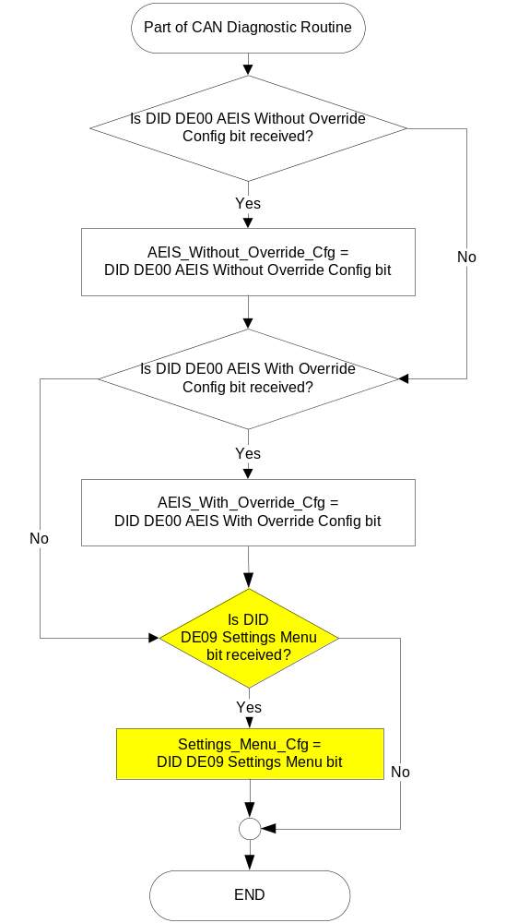

Figure 3. AEIS Centerstack Signal Gateway Routine Flowchart
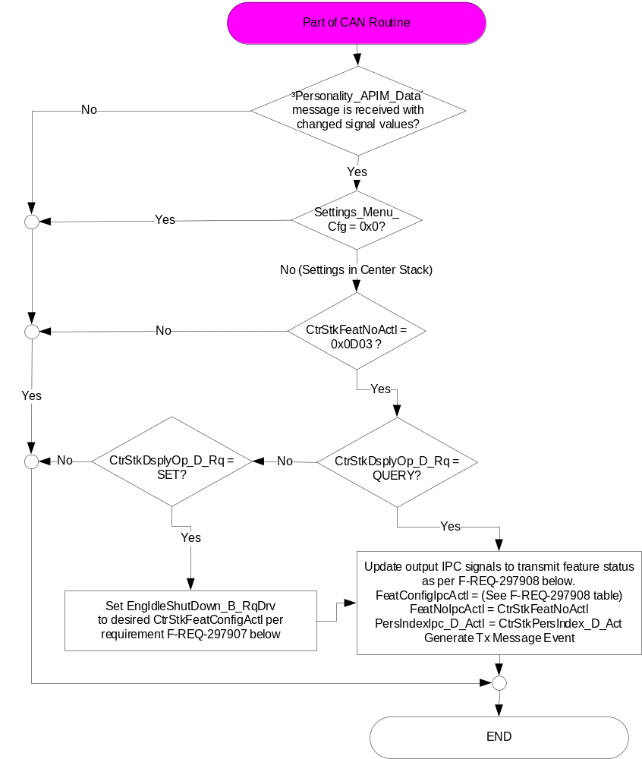

- EngIdleShutDown_B_RqDrv State based upon CtrStkFeatConfigActl
CtrStkFeatConfigActl  Signal | Display Menu  In Center Stack (For reference) | EngIdleShutDown_B_RqDrv Signal
On (0x1) | ☑ Auto Engine Off | 0x0 (No Inhibit)
Off (0x0) | ◻ Auto Engine Off | 0x1 (Inhibit)
Unused (0x2-0xFF) | ◻ Auto Engine Off | 0x0 (No Inhibit)

- FeatConfigIpcActl State based upon EngIdleShutDown_B_RqDrv
EngIdleShutDown_B_RqDrv Signal | Display Menu  In Center Stack (For reference) | CtrStkFeatNoActl  Signal | FeatConfigIpcActl  Signal
0x0 (No Inhibit) | ☑ Auto Engine Off | 0x0D03 | 0x1 (On)
0x1 (Inhibit) | ◻ Auto Engine Off | 0x0D03 | 0x0 (Off)

Figure 4. AEIS Cluster Settings and Warning Flowchart
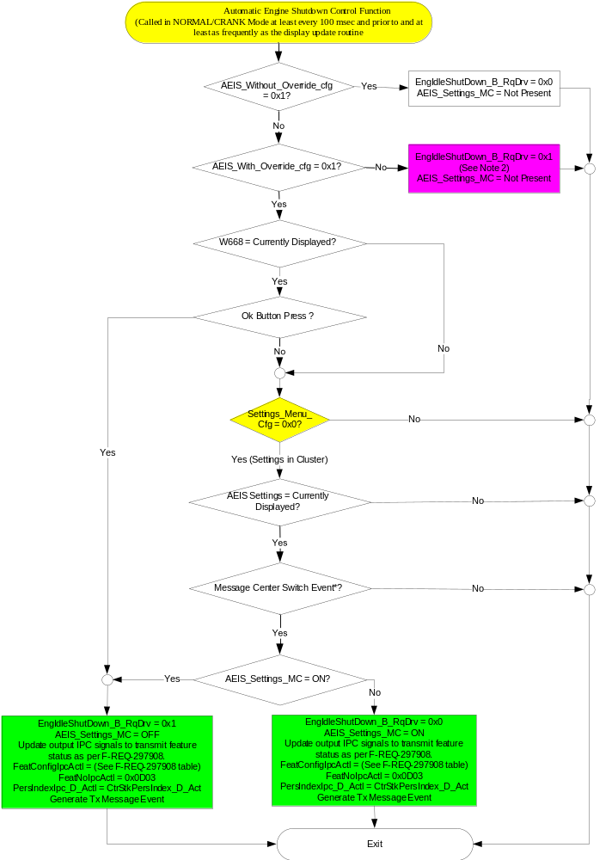

NOTE 1: In the Automatic Engine Shutdown Control Function Flowchart, the definition of "M/C Switch Event" is defined in Message Center X Display_Y Button Interface Section, where X and Y are appropriate values in this document.
NOTE 2: If “Warning - Police Idle System – CGEA 1.3” STSS is used in same software (per Police_Feature_Cfg = 0x1 (Enabled)), don’t update EngIdlShutDown_B_RqDrv signal so that “Warning - Police Idle System” STSS takes precedence on CAN output.

Operation Description (supports algorithm flowchart /state diagram)

- Message Center Display based upon AEIS_Settings_MC
EngIdlShutDown  _D_Stat | AEIS_Settings_MC  (per Figure 4) | Display Menu
X | ON | Auto Shutoff  
X | OFF | Auto Shutoff  
X | Not Present | Display Removed From Menu
Missing as per 1.4.1 | ON or OFF | Auto Shutoff  

- AEIS Warning Messages
Operational  _Mode | AEIS_Without  _Override_Cfg | AEIS_With  _Override_Cfg | EngIdlShut  Down_D  _Stat | Engine_Turning  _Off_MC  _Status_Flag | Engine_Turning  _Off_With  _Overide_MC  _Status_Flag | Engine_Off_MC_Status  _Flag
Normal or Crank | Enabled (0x1) | X | 0x1 | Active | Inactive | Inactive
Normal or Crank | Disabled (0x0) | Enabled (0x1) | 0x1 | Inactive | Active | Inactive
Normal or Crank | Enabled (0x1) | X | 0x2 | Inactive | Inactive | Active
Normal or Crank | Disabled (0x0) | Enabled (0x1) | 0x2 | Inactive | Inactive | Active
All Other Cases |  |  |  | Inactive

- AEIS Status Flag to Warning Message
Engine_Turning  _Off_MC  _Status_Flag | Engine_Turning  _Off_With  _Overide_MC  _Status_Flag | Engine_Off_MC  _Status_Flag | MC Warning Message ID | Active Chime_Status_Flag
Active | Inactive | Inactive | W665  Engine Shuts Off  In XX Seconds | Message_Center_Informational_Chime_Status_Flag
Inactive | Active | Inactive | W668  Engine Shuts Off  In XX Seconds  Push Ok to Override | Message_Center_Informational_Chime_Status_Flag
Inactive | Inactive | Active | W667  Engine Shut Off  For Fuel Economy | Message_Center_Informational_Chime_Status_Flag

Note: Text is for REFERENCE ONLY Text Message List is the Master

Figure 5 Detailed Function - Engine_Turning_Off_MC_Status_Flag

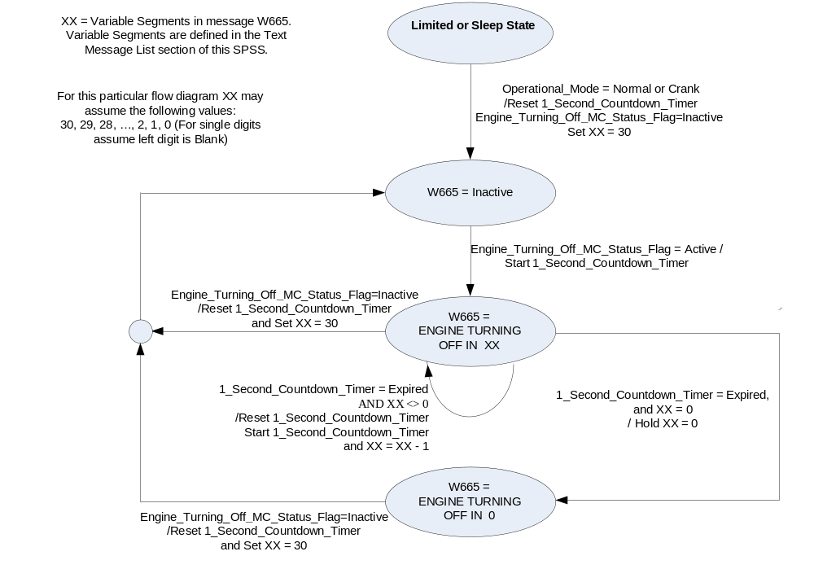

Figure 6: Engine_Turning_Off_With_Overide_MC_Status_Flag = Active – Detailed Function

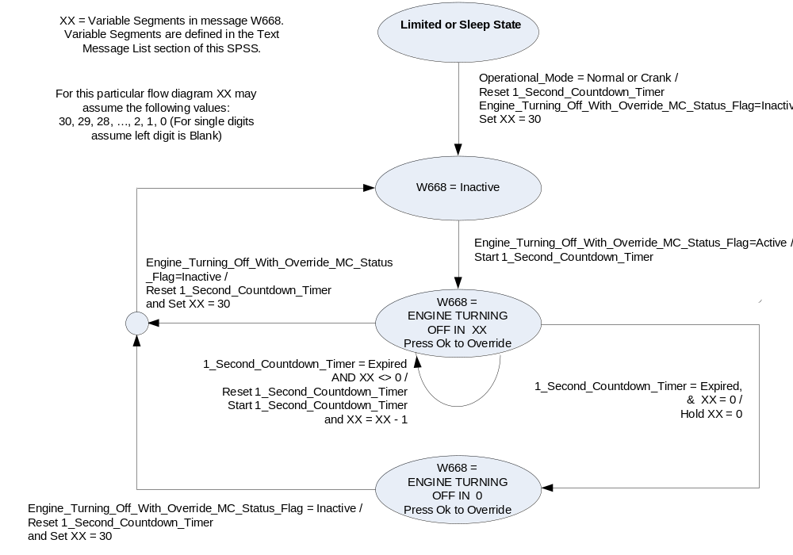

- Personalization Feature Number Definition:
Feature Name | Feature Num | Cfg Num | Cfg Value
Auto Engine OFF | 0x0D03 | 0x00 | OFF / Disabled
Auto Engine OFF | 0x0D03 | 0x01 | ON / Enabled

Function Safety Classification (EMC)

Class B

Memory Storage

Parameter Name | Description | Value at  Battery Connect | Value at  Module  Wake-up | Value upon entering Normal or Crank from Limited
AEIS_Settings_MC | Setting Menu Feature displayed in the M/C | On (0x1) | On (0x1) | On (0x1)
EngIdlShutdown_B_RqDrv Signal | Output Signal to indicate override/disable of AEIS | No Inhibit (0x0) | No Inhibit (0x0) | No Inhibit (0x0)
EngIdlShutDown_D_Stat Signal | Input signal sent from IPMA to indicate Feature Number. | Normal_Operation (0x0) | Normal_Operation (0x0) | Normal_Operation (0x0)
AEIS_Without_Override_Cfg | Configures cluster to allow AEIS without override (regulatory) to function. | Use Stored Value | Use Stored Value | Use Stored Value
AEIS_With_Override_Cfg | Configures cluster to allow AEIS with override to function. | Use Stored Value | Use Stored Value | Use Stored Value
Settings_Menu_Cfg | Configures cluster to display items in the Settings menu (Set to “cluster” at cluster supplier manufacturer plant) | Use Stored Value | Use Stored Value | Use Stored Value
Police_Feature_Cfg | State Indicator for feature presence controlled via CAN at EOL at supplier plant based on end item part number. Refer to “Warning – Police Idle System – CGEA 1.3” STSS. (Note this will not be supported on most programs) | Use Stored Value | Use Stored Value | Use Stored Value
M/C_Display_Status | State Indicator to identify which text is currently being displayed on Message Center display. See * | See * below | See * below | See * below
M/C Switch Event | Event that is indicated as per the switch interface for the Message Center. See * | See * below | See * below | See * below
Operational_Mode | 4 state indicator for cluster operational mode | Limited | Limited, Normal or Crank | Normal or Crank
Message_Center_Informational_  Chime_Status_Flag | Used to control the state of the chime to the Chime arbitrator | Inactive | Inactive | Inactive

* Refer to Message Center X Display Y Button Interface Section, where X and Y are appropriate values in this document.

Reconfigurable Telltale

Not Applicable

Prove Out

Not applicable

Message Center Msg

As per Table 1.13 AEIS Status Flag to Warning Message

Error Handling

Missing Message Strategy

The signals will be declared missing as per the Diagnostics section of this SPSS.

DTCs states and history will be determined as per the Diagnostics section of this SPSS.

If AEIS Without Override Config Bit = Disabled AND AEIS With Override Config Bit = Disabled, the cluster shall never log a missing message for this feature.

Diagnostics

Self Test

None

Engineering Test Mode

Reference section “Dealer / Engineering Test Mode (ETM)”

Part II Performance

Supported Diagnostic Trouble Codes (DTCs)
DTC | Description
C10000 | Lost communication with ECM/PCM for 5 seconds.

DID $DExx:
Block  Num | Block Description | Byte(s) | Bits | State: Description | "0" | "1" | Default | Comments/Information
PACKETED BLOCKS
$00 | Option Content (B&A) | * | * | AEIS Without Override  (Regulatory – CARB) | Disabled | Enabled | Disabled | Not Dealer Configurable  On SuperDuty and Heavy Truck (i.e. P558/H567, etc.), this feature is enabled for fleet owners on bladed key vehicles.  (needs direction from Powertrain)  All other vehicles:  Always set to 0 (Disabled).  The Automatic Engine Idle Shutdown (AEIS) feature, which will shut off the engine on a vehicle which sits at idle with no inputs from the driver for a period of time (30 minutes) in order to help improve fuel economy. This feature is implemented with and without customer override capability.  The AEIS without override (regulatory) is incorporated for fleet usage and possible future regulatory needs.  Regulatory - CARB. Automatic Engine Idle Shutdown selection menus and warnings for CARB-restricted vehicles (no user disable allowed)
$00 | Option Content (B&A) | * | * | AEIS With Override | Disabled | Enabled | Disabled | Dealer configurable to allow permanent disable.  This parameter allows the “Auto Engine Off” settings menu to be displayed in the cluster or Center Stack (since cluster is signal gateway for this feature). Menu display is determined by Settings Menu config.  Disabled means both message center and Center Stack setup feature is not present in the vehicle.  Allows Automatic Engine Idle Shutdown selection menus and warnings for non-CARB-restricted vehicles (user disable allowed)
$09 | Option Content (B&A) | * | * | Settings Menu | Cluster | Center Stack | Cluster | This parameter allows the Settings menu to be displayed in the cluster when 0x0. When 0x1, the expectation is that settings are displayed in the Centerstack. For this feature (when 0x1), the cluster will remove almost all items from settings menu. (Cluster display choices remain). Note this is a global config, each feature still has its own config for presence on vehicle.
 | *Byte and bit location to be identified in Part II Specification for this cluster

Reference Specification

None.

Revision History
SPSS Module Revision History
Revision Level | Name | Change Description | Date
1.0 | Jblatchf | Initial Release | 4/26/2011
1.1 | Jgregoir | Table 1.1 – Correct signal size (bits) to 1. | 10/28/2011
1.2 | Jblatchf | Corrected flow chart Figure 2 page 6 of 12. | 4/18/2012
1.3 | T. Cwik | This update is to make minor corrections and clarifications of the existing direction.  Section 1.2.2 – Table 1.0 – Updated the State Details to agree with the CAN dbc  Section 1.3.3.3 – Updated reference to Table 1.4  Section 1.3.5.1 –  – Figure 2 – Changed the Name of the 2nd flowchart and changed its note to reference the correct flowchart.  – Figure 3 – Added “AND X<> 0” in Path to and from “W665=…”  – Figure 4 – Added “AND X<> 0” in Path to and from “W668=…”  Section 1.3.5.4 – Updated State Details for EngIldShutDown_D_Stat | 1/23/2013
1.4 | Ilopezla | This Update is to inform which Chime Status Flag is associated with this warning  Section 1.2.1- Figure 2-Added Message_Center_Informational_Chime_Status_Flag  Section 1.2.3-Added Message_Center_Informational_Chime_Status_Flag  Section 1.3.3.3- Added Message_Center_Informational_Chime_Status_Flag  Section 1.3.5.2 - Table 1.4-Corrected flag name to Message_Center_Informational_Chime_Status_Flag  Section 1.3.5.4- Added Message_Center_Informational_Chime_Status_Flag as a parameter | 11/30/2016
2.0 | S. Watkins | Starting in MY2019 with U625/U611 the Settings are migrating from the cluster to Centerstack. This STSS update is to support this effort. A configuration is added to ensure backward compatiblity.  Changes shown in yellow:  - Section 1.1 – Updated description  - Section 1.2.1 – Added a config, 4 input signals and 3 output signals  - Section 1.2.2 – Added Setting_Menu_Cfg and 4 new signals  - Section 1.2.3 – Added 3 new signals  - Section 1.3.5.1 – Figure 2 – Added Settings_Menu_Cfg. Added new Figure 3. Modified Figure 4 to add decision diamond for Settings_Menu_Cfg. Added new Table 1.9 and Table 1.10.  - Section 1.3.5.2 – Added Table 1.14 Feature Number definition for AEIS.  - Section 1.5.3 – Modified description of AEIS Function configs and added new Settings Menu config to DExx | 1/21/2017
2.1 | S. Watkins | A supplier pointed out a defect in Figure 4 (AEIS Cluster Settings and Warning Flowchart). Once the user changes the AEIS setting using W668, we are not generating an update to Feature Config signals for 0x0D03.  Changes in green:  - Section 1.1 – Updated description  - Section 1.3.5.1 – Figure 4 (AEIS Cluster Settings and Warning Flowchart) – Updated 2 action boxes at the bottom to show the Feature Config signals being transmitted. | 2/18/2018
2.2 | A.Mufid | Initial VSEM RM Release | 03/07/2018
2.3 | A. Mufid | 1-Fixed broken tables and figures and added table repeated header  2-Importing Visio objects issue were fixed by D. Nosov | 9/13/2018
2.4 | S. Watkins | Cleanup per supplier Q&A. First, updated Figure to clarify that when you get a QUERY or SET for Feature Number 0x0D03, that you respond back with Feature Number 0x0D03. Also, same Figure was modified to clarify that when you receive a SET comand, you must respond. Finally, for police vehicles, there is an output CAN signal conflict that occurs when you implement both this STSS and the “Warning – Police Idle System – CGEA 1.3” STSS.  Changes in purple:  - Section 1.2.1 – Added Police_Feature_Cfg  - Section 1.2.2.1 - Added Police_Feature_Cfg  - Section 1.3.5.2 – Changed flow from bottom left action box to exit to the right adjacent action box (instead of exiting downward and out).  - Section 1.3.5.4 – Added column with 0x0D03 for clarity  - Section 1.3.5.5 – Added reference to Note 2 to action box, as well as Note 2 below figure.  - Section 1.3.5.4 – Added Police_Feature_Cfg | 10/18/2018

